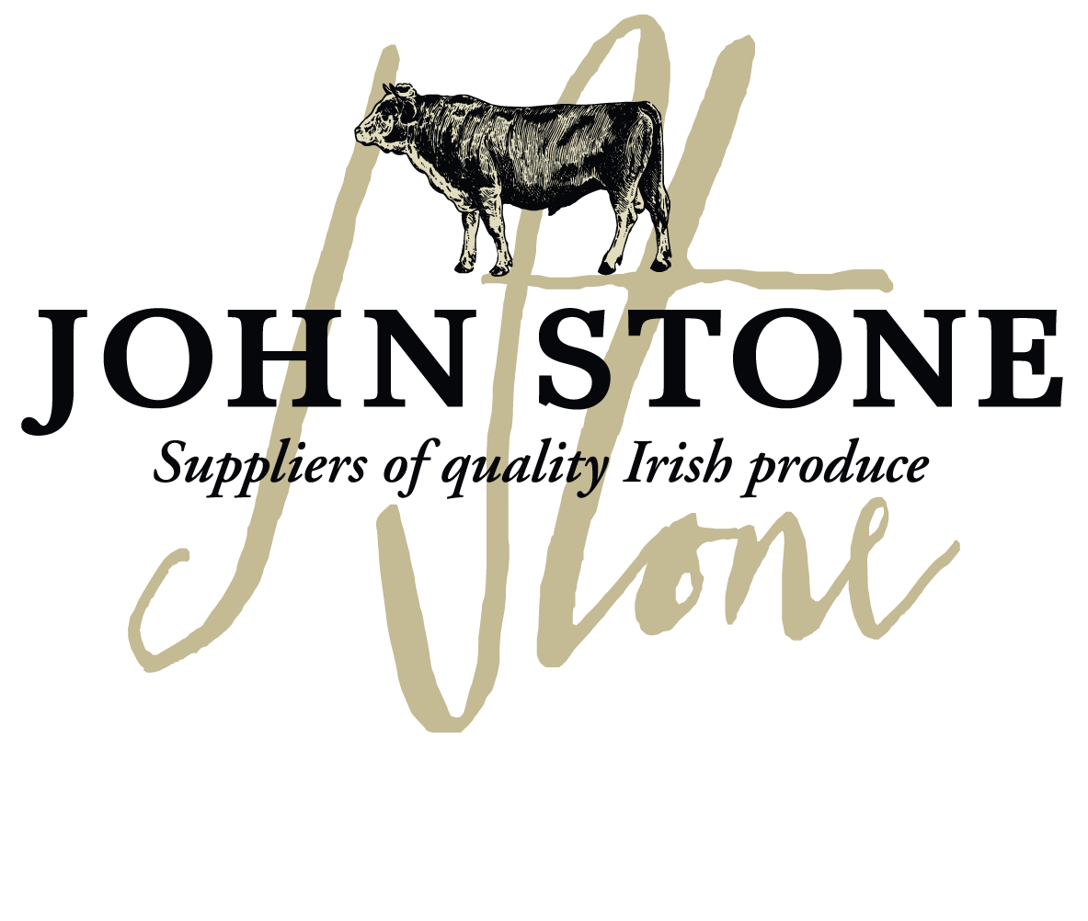

DETAILS ON THIS SPECIFICATION MUST NOT BE CHANGED WITHOUT PRIOR AGREEMENT

Selection of carcases | - The lamb will be sourced from
Cutting Spec | - Taken from the leg. Shank and femur bone removed. Chump remains.
Maturation  Shelf Life | - All lamb to be dry aged for a maximum of 21 days on the bone before dispatch unless prior agreement with customer  - pH max 5.8  - Shelf life 365 days from frozen
Packaging  Specification | - 1 piece per bag  - 15 packs per large case  - One label per piece to include all relevant data of slaughter and processing
Labelling | - Product name  - Batch code, slaughter and cutting plant number, country of origin, storage instructions & typical nutritional values  - Kill date, production date, use by date  - EAN 128 barcode on label
Carton | - Full colour Print lid, Double corrugated base double strapped. Full label and health stamps

Nutritional information:
Typical per 100g | Result | Unit(s)
Energy kJ |  | KJ/100g
Energy kCal |  | kcal/100g
Fat |  | g/100g
of which saturates |  | g/100g
Carbohydrates |  | g/100g
of which sugars |  | g/100g
Protein |  | g/100g
Salt |  | g/100g
Allergen information:
Contains 100% irish lamb

Labels:
Product label | Outer Case Marker label

Information on labels such as production and kill dates, best before dates, weight and batch numbers are examples only

