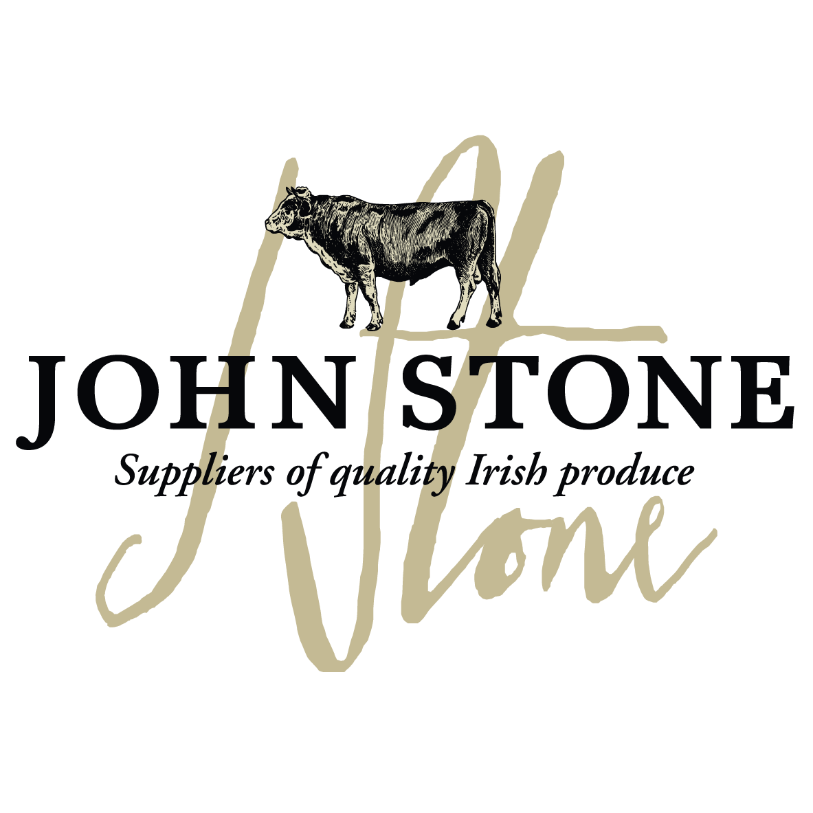

DETAILS ON THIS SPECIFICATION MUST NOT BE CHANGED WITHOUT PRIOR AGREEMENT
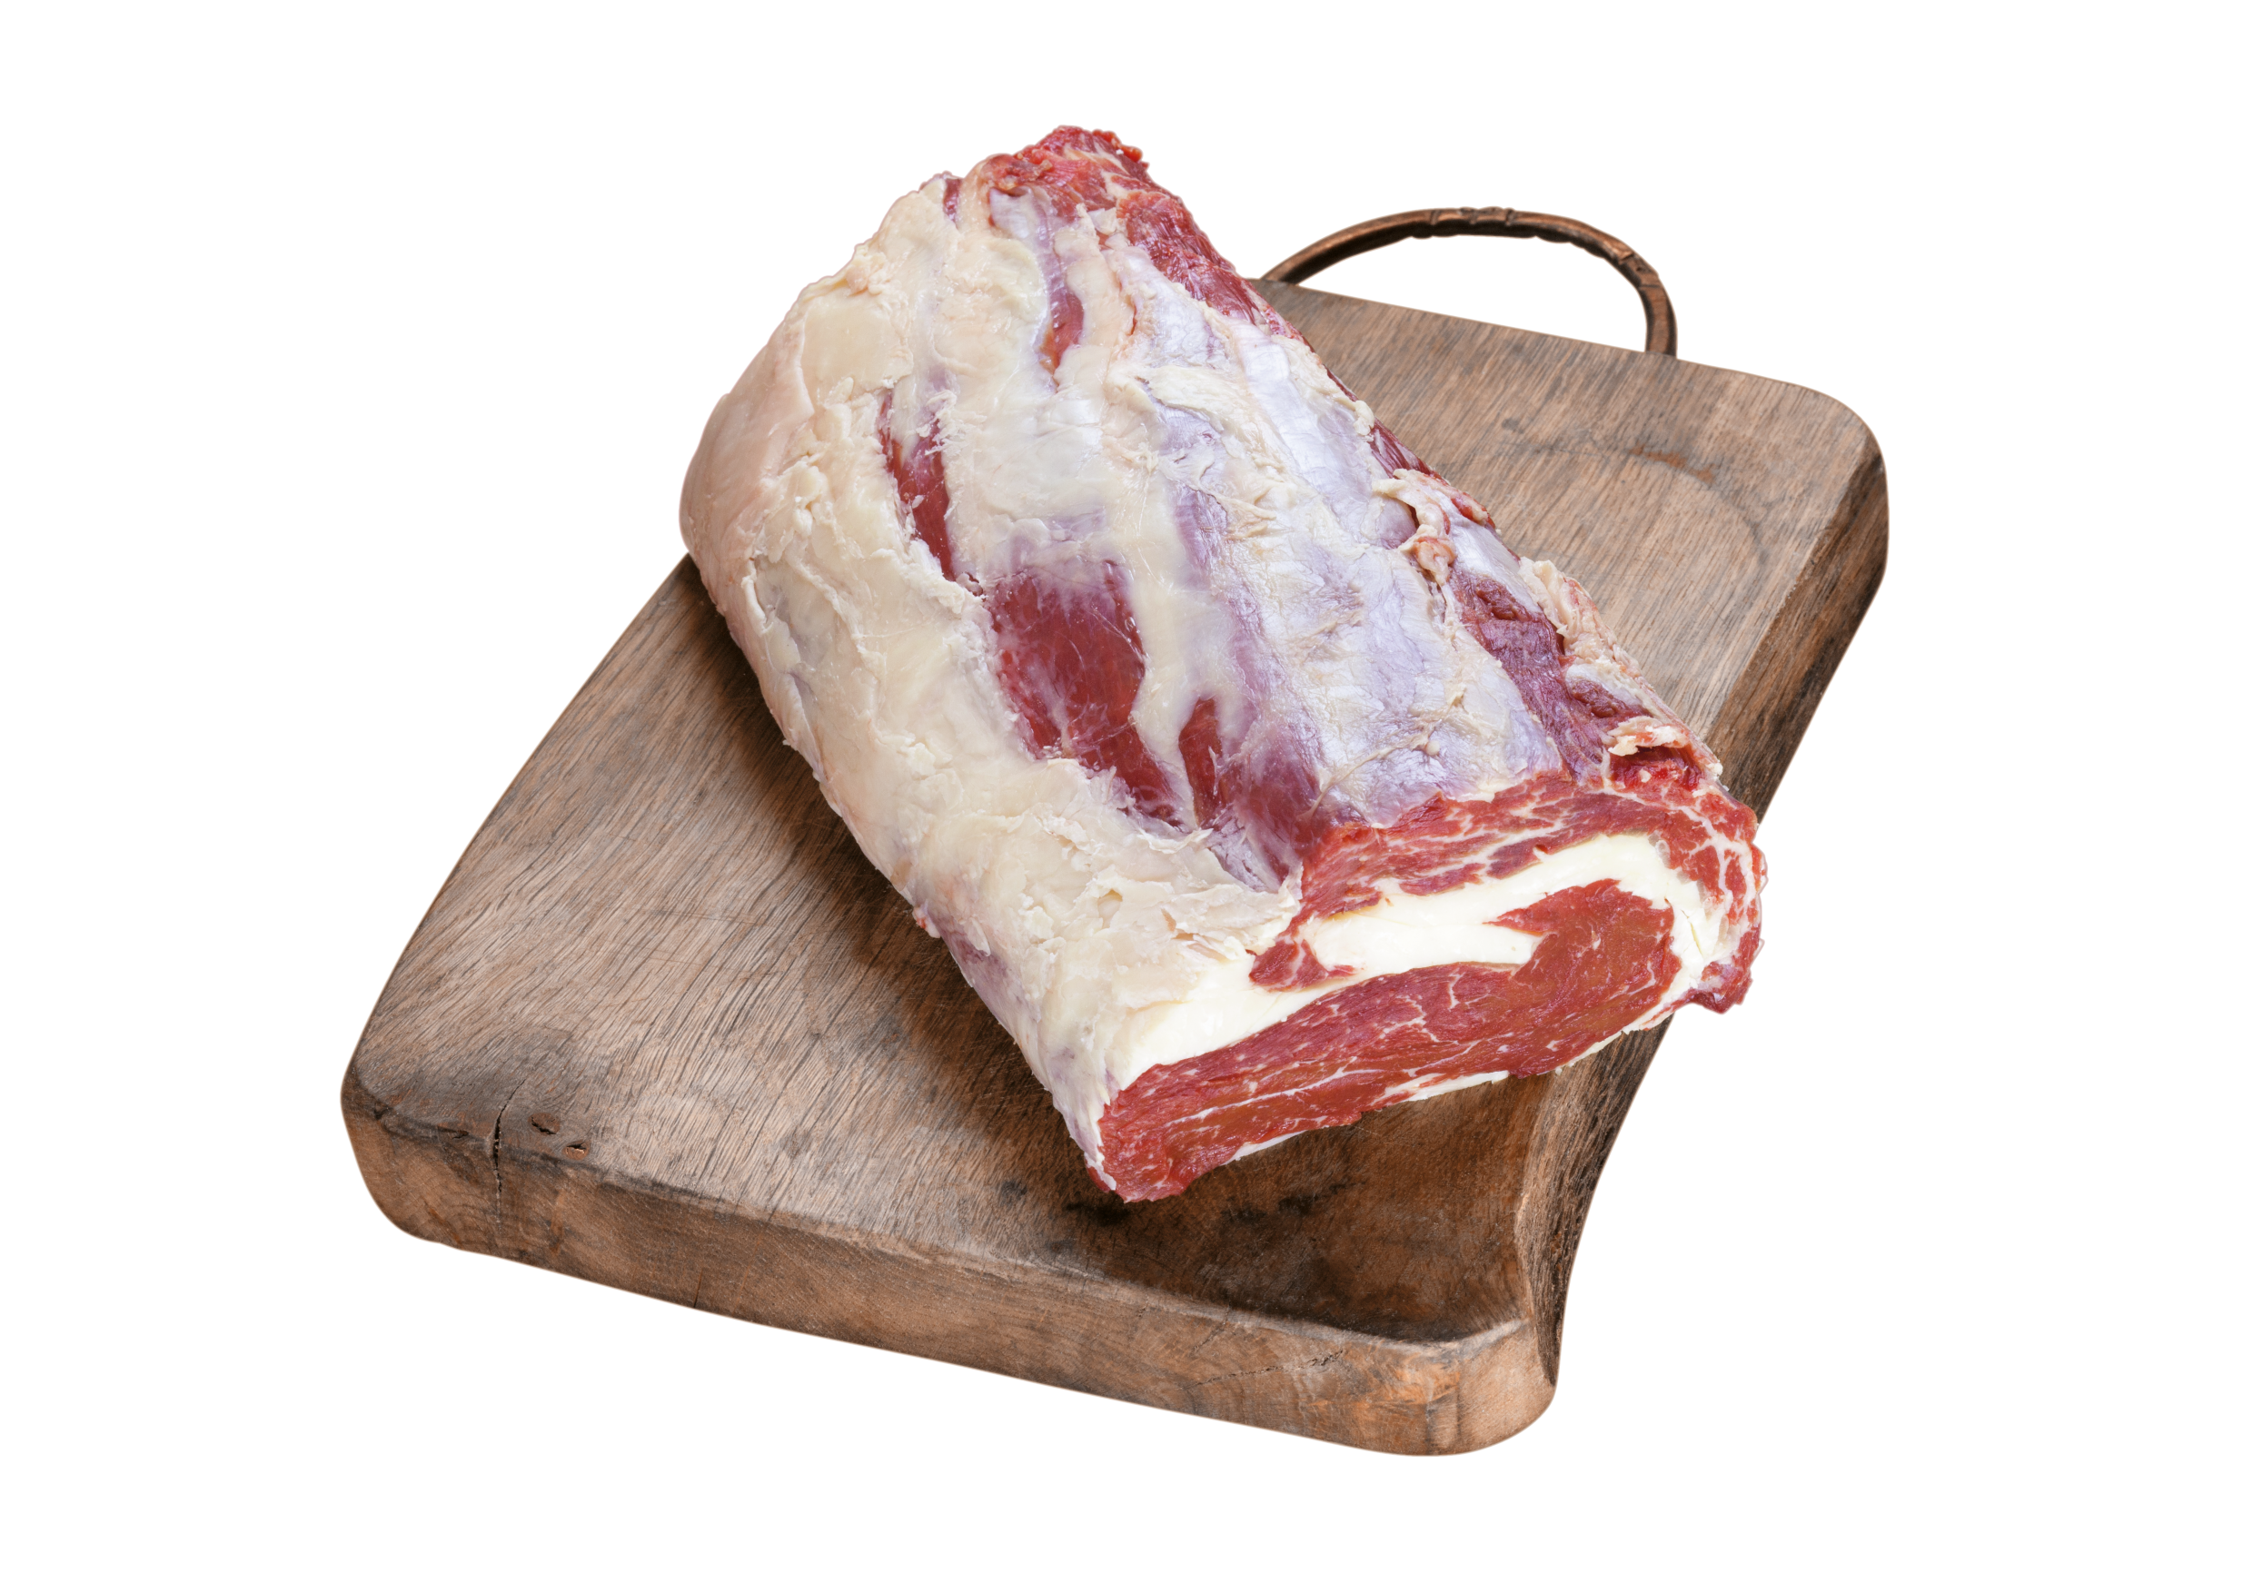

Selection of carcases | - The Ribeye Roll will be sourced from farm assured steers and heifers of up to 30 months old. From grades EUR 4L, 4H & 5.
Cutting Spec | - Prepared from the Fore Rib, bone and cap removed. Central eye muscle removed and trimmed. Membrain remains on top in order to hold the muscles together. Ends are squared.
Maturation  Shelf Life | - All beef to be dry aged for a maximum of 21 days on the bone before dispatch unless prior agreement with customer  - pH max 5.8  - Shelf life 28 days from pack
Packaging  Specification | - 1 piece per bag  - 8 packs per large case  - One label per piece to include all relevant data of slaughter and processing
Labelling | - Product name  - Batch code, slaughter and cutting plant number, country of origin, storage instructions & typical nutritional values  - Kill date, production date, use by date  - EAN 128 barcode on label
Carton | - Full colour Print lid, Double corrugated base double strapped. Full label and health stamps

Allergen information:
Contains 100% irish beef

Labels:
Product label | Outer Case Marker label
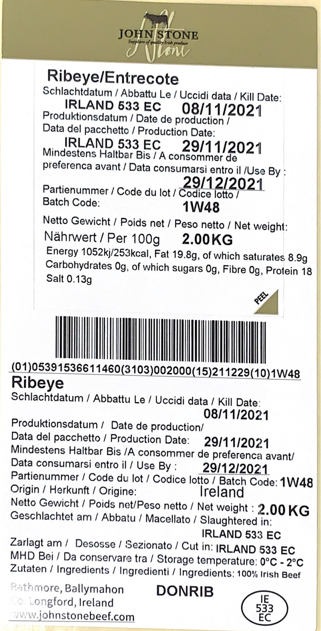 | 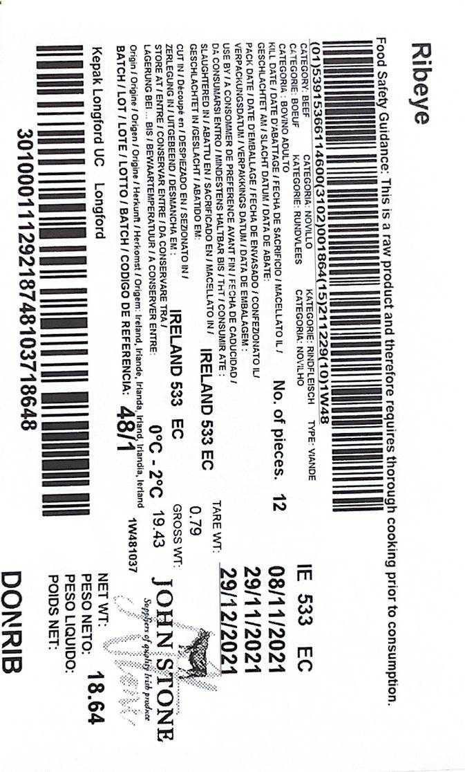

Information on labels such as production and kill dates, best before dates, weight and batch numbers are examples only

