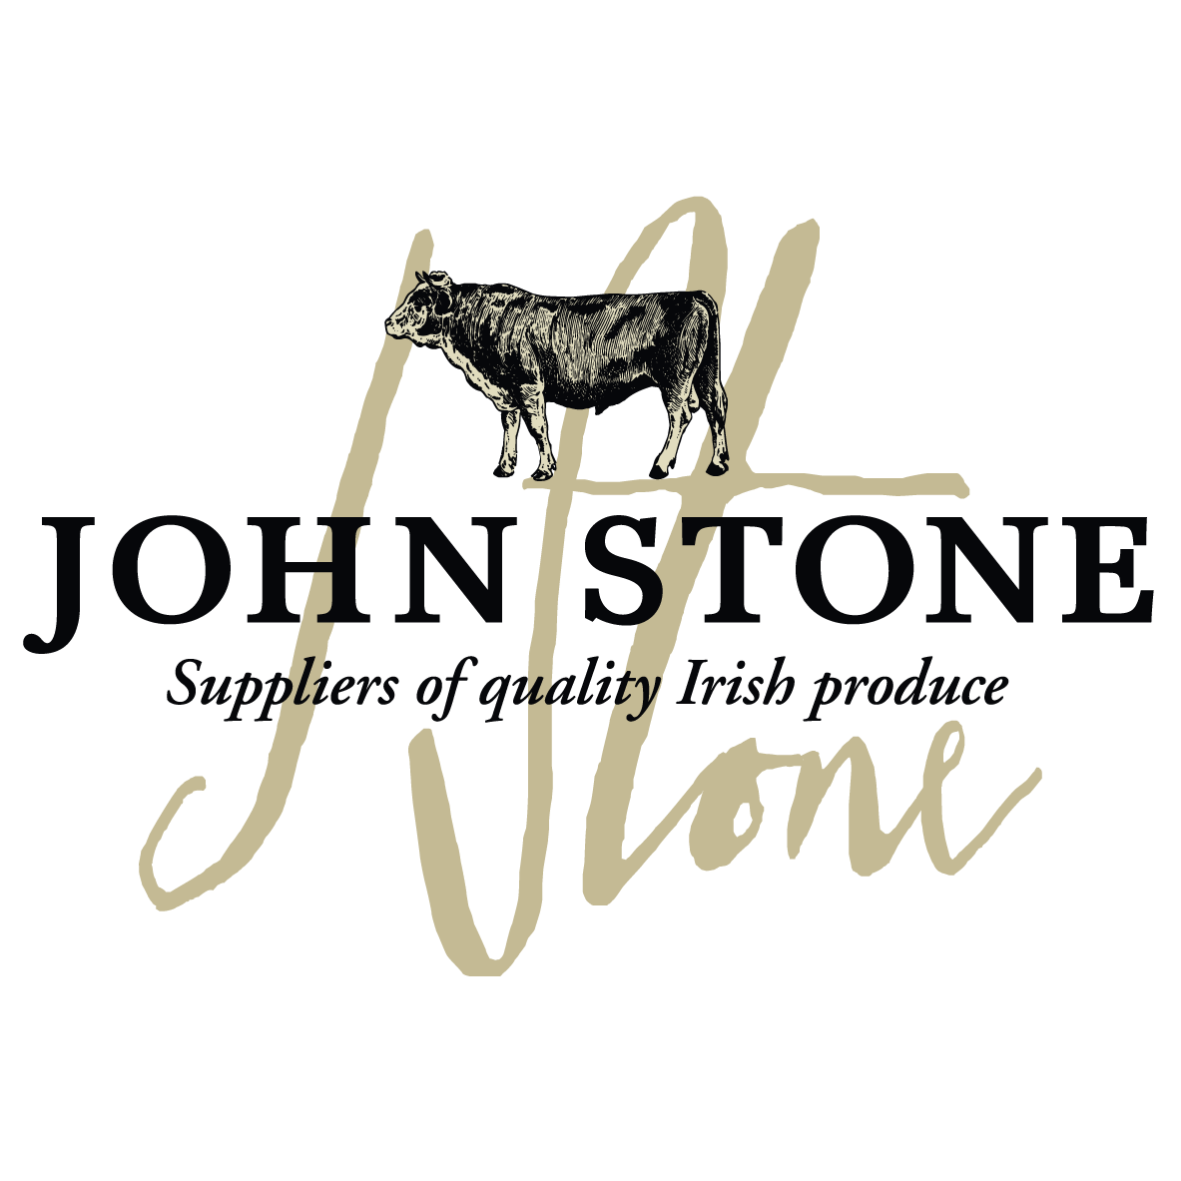

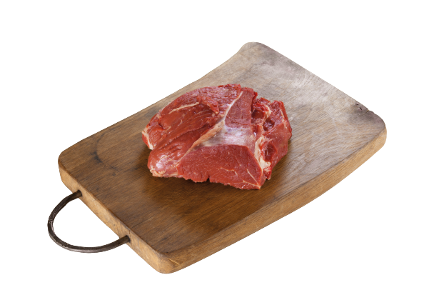
DETAILS ON THIS SPECIFICATION MUST NOT BE CHANGED WITHOUT PRIOR AGREEMENT

Selection of carcases | - The fillet will be sourced from farm assured steers and heifers of up to 30 months old.
Cutting Spec | - Removed from the striploin. Fillet chain, fat and surface membrane are removed. Tail removed up to point of 50-60mm. Head removed at point where head and loin meet.
Maturation  Shelf Life | - All beef to be dry aged for a maximum of 21 days on the bone before dispatch unless prior agreement with customer  - pH max 5.8  - Shelf life 28 days from pack
Packaging  Specification | - 1 piece per bag  - 20 packs per large case  - One label per piece to include all relevant data of slaughter and processing
Labelling | - Product name  - Batch code, slaughter and cutting plant number, country of origin, storage instructions & typical nutritional values  - Kill date, production date, use by date
Carton | - Full colour Print lid, Double corrugated base double strapped. Full label and health stamps

Allergen information:
Contains 100% irish beef

Labels:
Product label | Outer Case Marker label
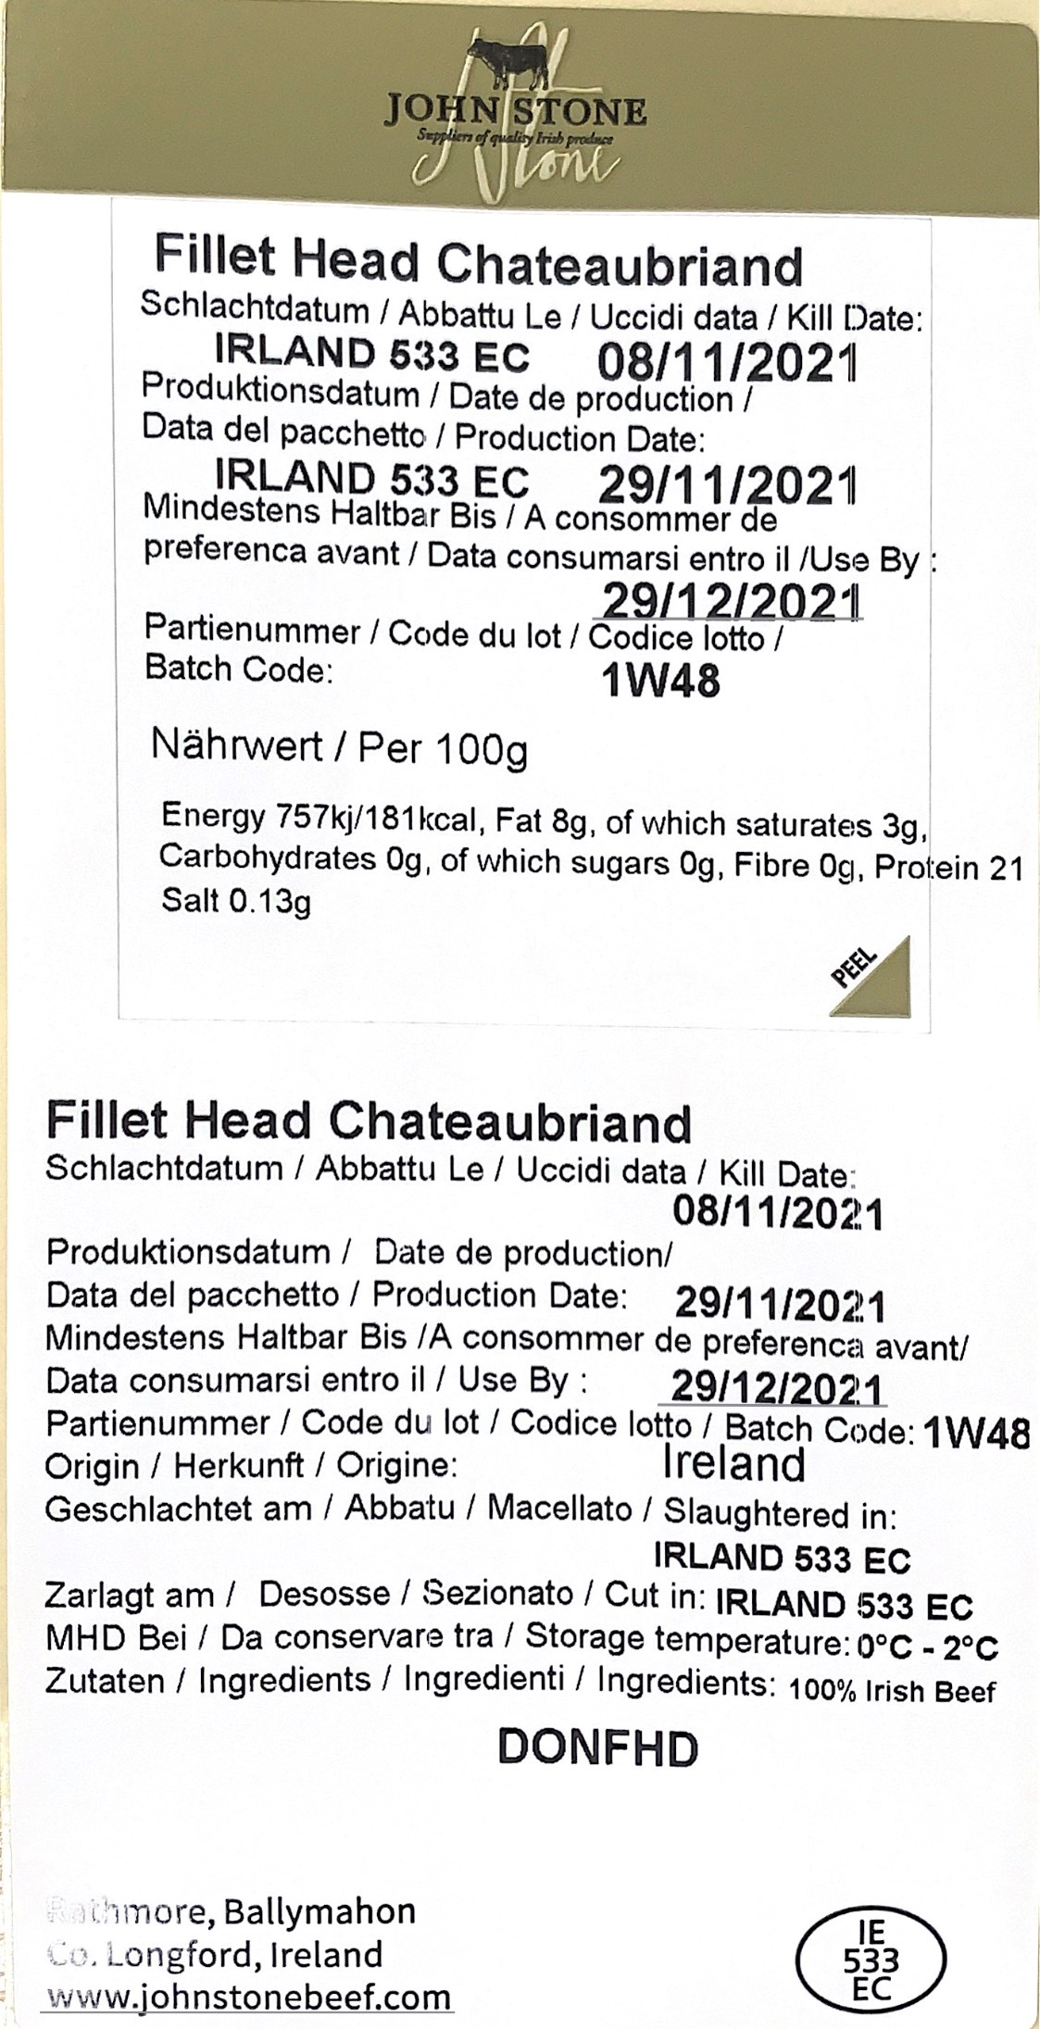 | 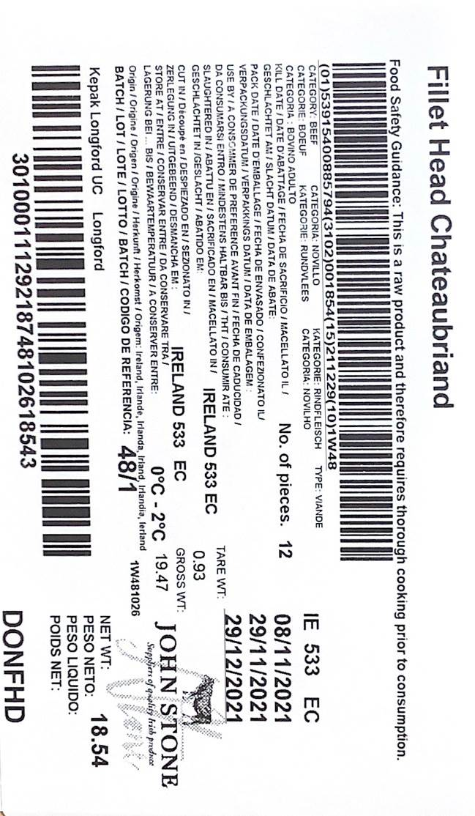

Information on labels such as production and kill dates, best before dates, weight and batch numbers are examples only

