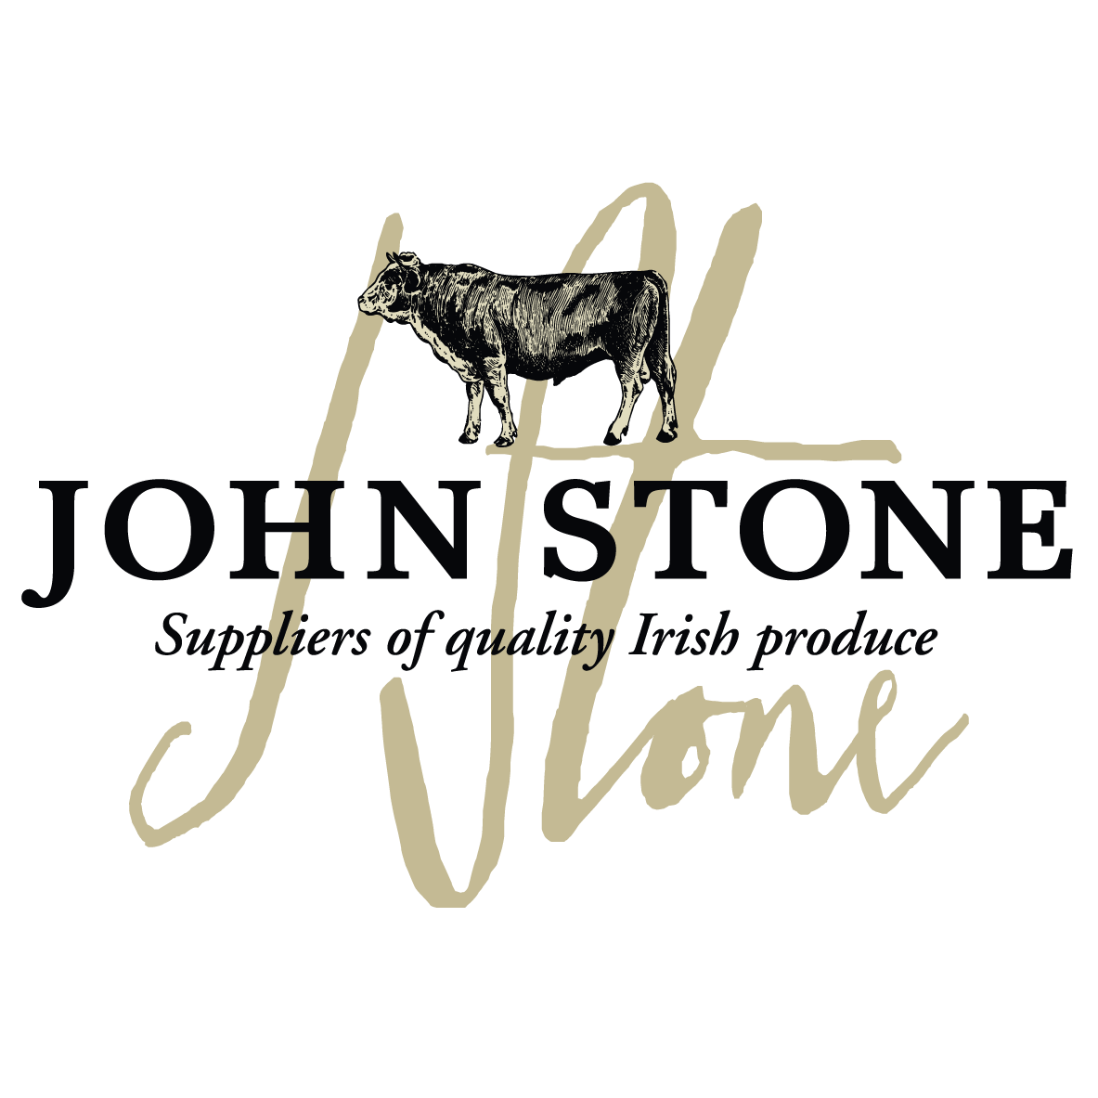

DETAILS ON THIS SPECIFICATION MUST NOT BE CHANGED WITHOUT PRIOR AGREEMENT

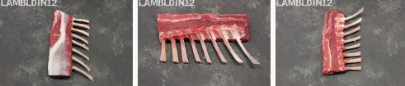

Selection of carcases | - The lamb will be sourced from Athleague EC313
Cutting Spec | - Taken from the 8 rib lamb middle. Lamb middle split in half. Bone in breast removed with the bandsaw 50mm from the eye, leaving a 50mm loin. Loin split leaving a centreloin and a rack end. Moonbones removed from rack end. Chine bone and rack cap removed. Rack is french trimmed all the way back to the eye from the tip of the bone. Rack lightly trimmed to tidy up.  - Chilled
Shelf Life | - 28 days from packing
Packaging  Specification | - 2 pieces per bag  - 15 packs per large case  - One label per piece to include all relevant data of slaughter and processing
Labelling | - Product name  - Batch code, slaughter and cutting plant number, country of origin, storage instructions & typical nutritional values  - Kill date, production date, use by date
Carton | - Full colour Print lid, Double corrugated base double strapped. Full label and health stamps

Allergen information:
Contains 100% irish lamb

Labels:
Product label | Outer Case Marker label
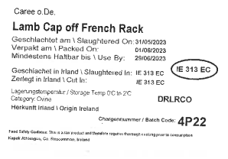 | 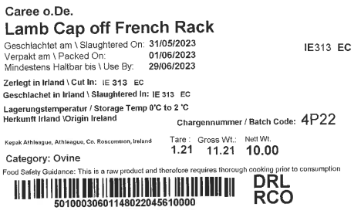

Information on labels such as production and kill dates, best before dates, weight and batch numbers are examples only

