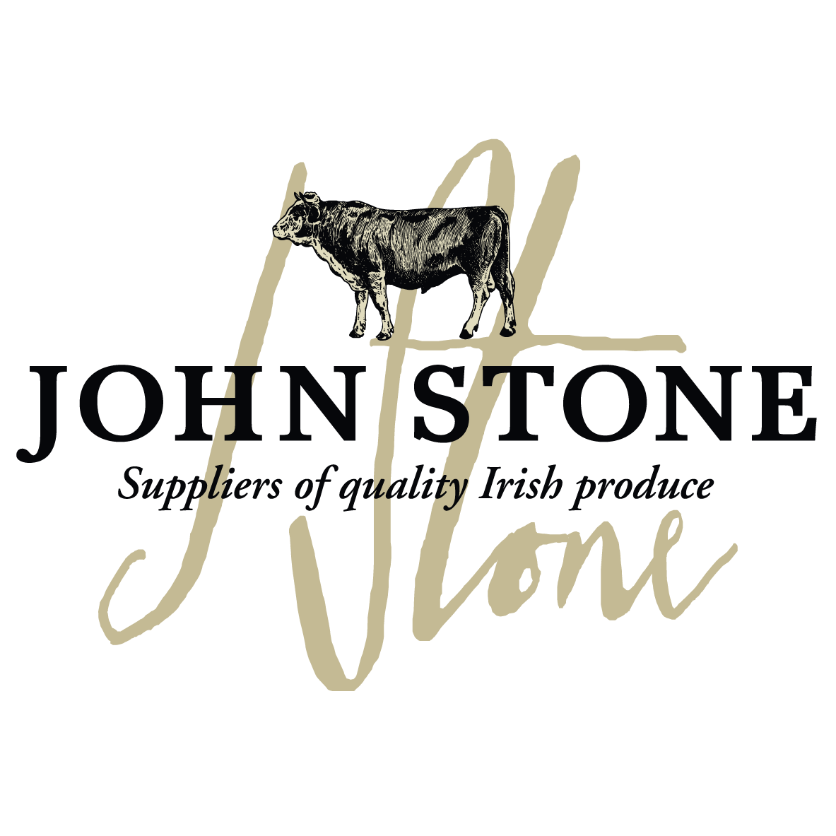

DETAILS ON THIS SPECIFICATION MUST NOT BE CHANGED WITHOUT PRIOR AGREEMENT

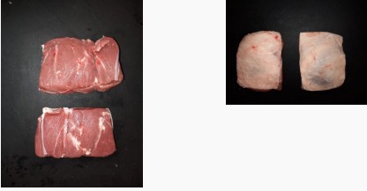

Selection of carcases | - The lamb will be sourced from  Athleague EC313  - Selected from lambs aged from 3 months to 12 months old
Cutting Spec | - Bark Removed. Fillet end removed  - Chilled
Shelf Life | - 28 days from packing
Packaging  Specification | - 4 piece per bag  - 8 packs per large case  - One label per piece to include all relevant data of slaughter and processing
Labelling | - Product name  - Batch code, slaughter and cutting plant number, country of origin, storage instructions & typical nutritional values  - Kill date, production date, use by date
Carton | - Full colour Print lid, Double corrugated base double strapped. Full label and health stamps

Allergen information
Contains 100% irish

Labels:
Product label | Outer Case Marker label
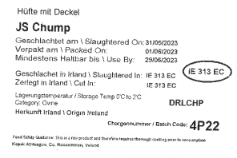 | 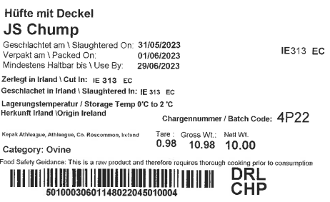

Information on labels such as production and kill dates, best before dates, weight and batch numbers are examples only

