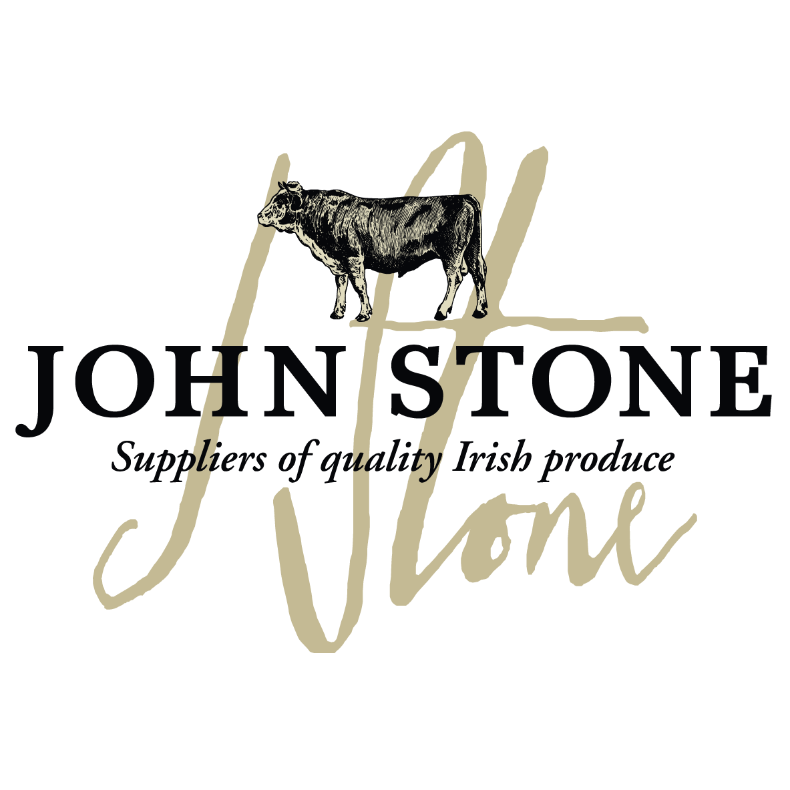

DETAILS ON THIS SPECIFICATION MUST NOT BE CHANGED WITHOUT PRIOR AGREEMENT

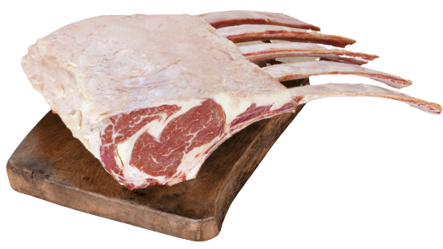

Selection of carcases | - The Rib will be sourced from farm assured steers and heifers of up to 30 months old. From grades EUR 4L, 4H & 5.
Cutting Spec | - Prepared from the Fore RIB. Spinal bone column removed. Cap removed, leaving the rib bones intact. Bones cleaned by removing central rib trim. Membrane remains in order to hold the muscle and remaining bones together. The ends of aged bones sawn. Max length of bone from lip is 9.5 inches.
Maturation  Shelf Life | - All beef to be dry aged for a maximum of 21 days on the bone before dispatch unless prior agreement with customer  - pH max 5.8  - Shelf life 28 days from pack
Packaging  Specification | - 1 piece per bag  - 2 packs per large case  - One label per piece to include all relevant data of slaughter and processing
Labelling | - Product name  - Batch code, slaughter and cutting plant number, country of origin, storage instructions & typical nutritional values  - Kill date, production date, use by date  - EAN 128 barcode on label
Carton | - Full colour Print lid, Double corrugated base double strapped. Full label and health stamps

Allergen information:
Contains 100% irish beef

Labels:
Product label | Outer Case Marker label
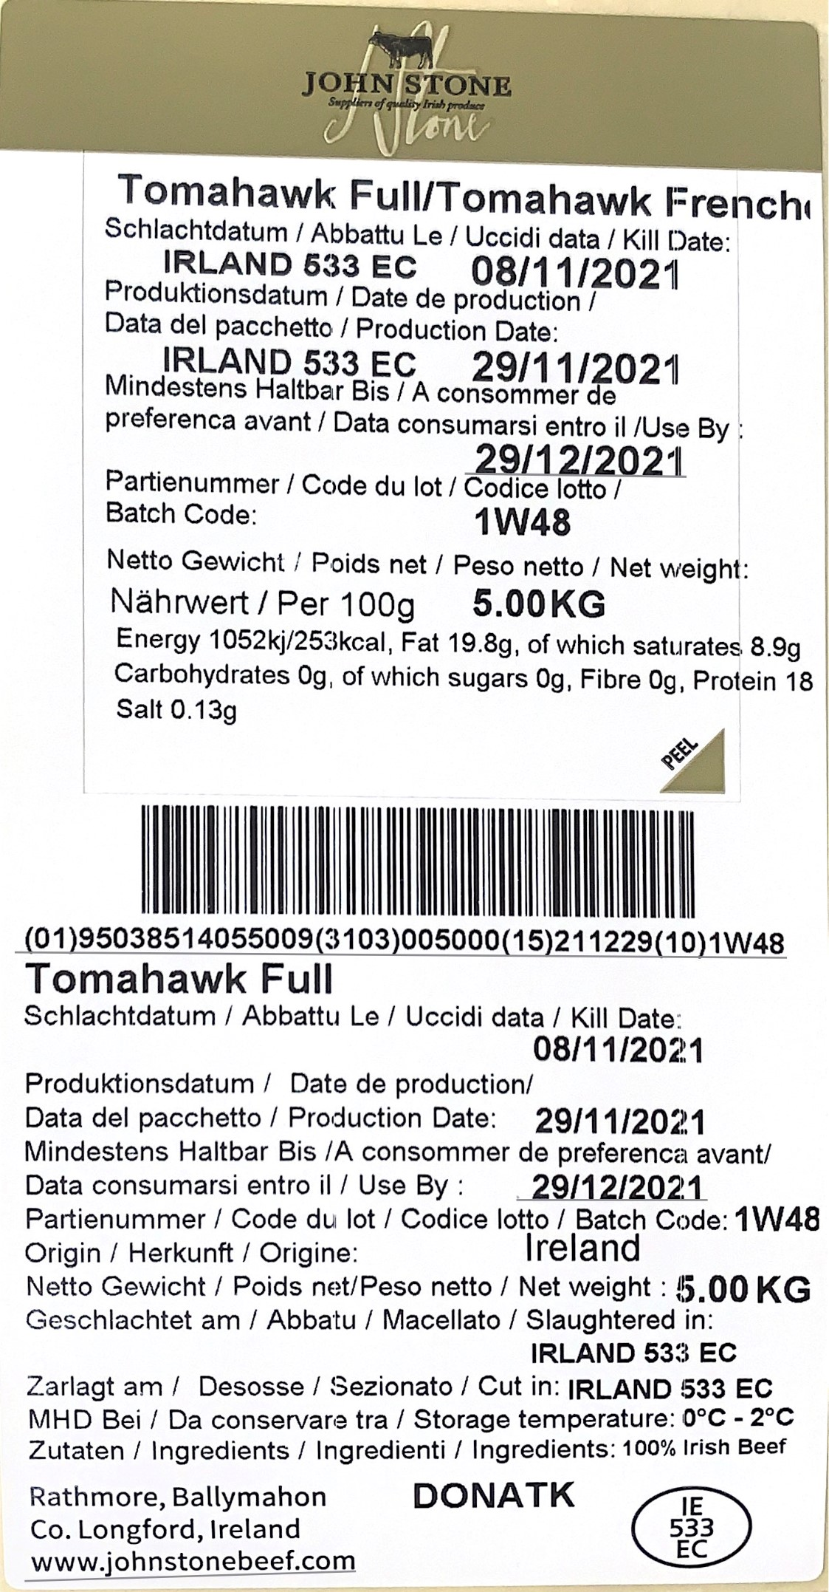 | 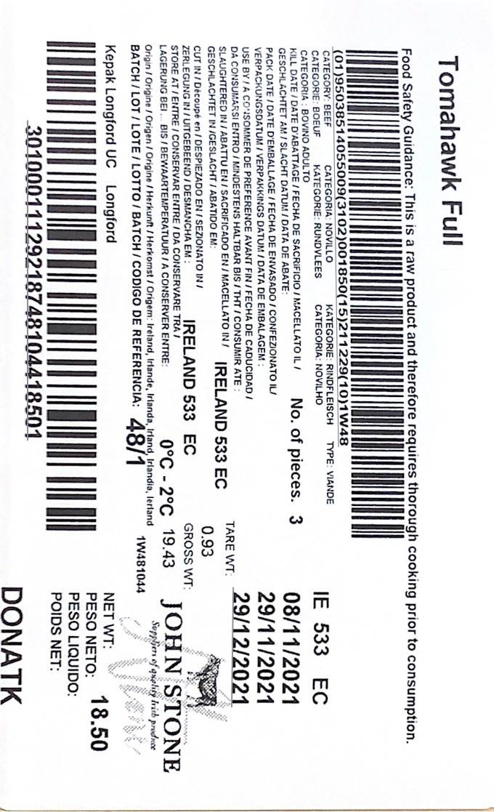

Information on labels such as production and kill dates, best before dates, weight and batch numbers are examples only

